

BEhaviour & Relationships policy

This Policy was formally adopted by the Governing Body on
February 2026

Staff were consulted in January 2026

Policy to be reviewed annually

Next review date February 2027

Summary of Recent Updates and Changes

Date | Description

Index
1. Aim of the Policy 3
2. Trauma Perceptive Practice 3
3. Roles and responsibilities 3
4. Encouraging Good Behaviour 5
5. Rewarding Good Behaviour 6
6. How we Support our Learners and Young People 6
7. Managing Undesirable Behaviour 7
6. Bullying 10
7. Responding to misbehaviour from children with SEND 10
8. Recording / Reporting of Behaviour Incidents 12
9. Harm from Dysregulated (stressed) Behaviour 12
10. Transitions 13
11. Safeguarding 13
12. Risk Assessment Process 13
13. Reasonable force 13
14. Confiscation and searches 14
15. Mobile phones 17
16. Off-site misbehaviour 17
17. Zero-tolerance approach to sexual harassment and sexual violence 18
18. Malicious allegations 19
19. Professional Development for Staff 19
20. Suspension and Permanent Exclusion 19
Appendix 1: Steps to dealing with difficult behaviour 21
Appendix 2 - Runwell Community Primary Level of Rewards 11
Appendix 3 - Runwell Community Primary School Levels of Behaviour 12
12
Appendix 4 - Behaviour Modification Card 13
Appendix 5 - 5 Step Adult Response Strategy Plan 14
Appendix 6 – Risk Assessment Guidance 16
Appendix 7 - Consistent Management Plan 11
Appendix 8 – Restorative Meeting Record 12
Appendix 9 – Restorative Conversation Prompts for Lanyards 13
Appendix 10 – De-escalation Script for lanyards 13
Appendix 11 – Co regulation Script for lanyards 13
Appendix 12 - SLANT and Walkwell 1
Appendix 13 - Reasons for suspension / permanent exclusion 2

- Aim of the Policy
Our school recognises that ‘all behaviour is communication’ [this is the first principle of a Nurture approach] and we will, therefore, endeavour to do our best to support learners with behavioural challenges, making reasonable adjustments.
We teach the learners at Runwell Community Primary School to behave as responsible, thoughtful, and caring individuals who can learn effectively and develop their self-esteem and build resilience so that they may achieve their potential. We want them to take pride in their school, we want them to aspire, believe and connect with the school and wider community. We expect them to conform to sensible, practical rules, designed to ensure the smooth running of the school and the safety and well-being of all. It is important that all adults within the school set a positive example for the learners and provide a working environment which is well planned, nurturing, and stimulating. We believe that everyone involved in the school should feel safe, valued, and respected. We believe that consistent boundaries and approaches help the children to feel safe and secure. When children feel safe and secure, they are ready to learn.
This policy aims to:
- Create a positive culture that promotes outstanding behaviour, ensuring that all pupils have the opportunity to learn in a calm, safe and supportive environment
- Establish a whole-school approach to maintaining high standards of behaviour that reflect the values of the school
- Outline the expectations and consequences of behaviour
- Provide a consistent approach to behaviour management that is applied equally to all pupils
- Define what we consider to be unacceptable behaviour, including bullying and discrimination
- Trauma Perceptive Practice
Our school reflects the values of the Essex Approach to understanding behaviour and supporting emotional wellbeing known as Trauma Perceptive Practice (TPP)
- Compassion and Kindness
- Hope
- Connection and Belonging
Our staff are Trauma Perceptive in their approach to supporting children’s emotional wellbeing and behaviour. This means they have received training in the psychology and neuroscience related to attachment and the impact of trauma on brain development and learning. A Trauma Perceptive approach to behaviour includes:
- Developing an understanding of how children and their families can be affected by early life stress and trauma
- Building consistent, positive and nurturing relationships with children
- Understanding children and young peoples’ communicating behaviours and stress responses
- Providing targeted support and appropriate interventions when required
We endeavour to make sure that at our school these values run through all the school policies and practice.
- Roles and responsibilities
All pupils should:
- Treat all children and all adults fairly and with respect
- Take responsibility for their own actions and behaviour and be honest
- Take responsibility for their own learning and allow other children to learn
- Follow the instructions of the teaching and support staff and cooperate with others
- Take care of property and the environment in and out of school
- Ensure they use e-communication safely and sensibly
All staff should:
- Take joint responsibility for managing the behaviour of all children in the school
- Meet and greet all children at the door or on the playground
- Create a safe learning environment, both physically and emotionally
- Communicating the school’s expectations, routines, values and standards through teaching behaviour and in every interaction with pupils
- Act as a role model for desired behaviour, treating all adults and children with respect, speaking in an appropriate manner at all times
- Respond promptly, calmly and predictably when implementing the behaviour policy. Use rewards and consequences consistently and fairly, without prejudice or bias and considering each individual child's age and needs
- Focus on good behaviour and positive reinforcement to raise self-esteem, acknowledging and giving praise for good behaviour and achievements
- Make children aware of the school behaviour standards, expectations, pastoral support available and consequence processes. This includes an induction process and extra support for pupils who are new to the school
- Recognise that each child is an individual, and to be aware of their (special) needs
- As far as possible, anticipate likely triggers of misbehaviour and put in place support to prevent these. Work in partnership with parents in managing any behavioural issues, ensuring that they are kept informed of all behavioural concerns relating to their child
- Record behaviour incidents promptly via CPOMS using STAR analysis
- Offer a framework for exploring behavioural issues through the PSHE (Personal, Social and Health Education) and SMSC (Spiritual, Moral, Social and Cultural) curriculum and through the use of Circle Time and/or class discussions
- Complete Trauma Perceptive Practice training. This includes induction training for new members of staff.
- Use e-communication safely and follow the Code of Conduct for Staff behaviour
The senior leadership team (SLT) will support staff in responding to behaviour incidents.
Parents should:
- Make children aware of appropriate behaviour in all situations.
- Encourage independence and self-discipline.
- Show an interest in all that their child does in school.
- Foster good relationships with the school.
- Support the school in the implementation of this policy
- Be aware of the school rules and expectations and to support the children in their understanding of these rules and expectations.
- Respect our school values and our ethos.
- Inform the class teacher of any change in circumstances that may impact on the child’s behaviour.
- Approach the school to help resolve any issues of concern.
- Follow the CLP Trust’s Parent and Visitor Code of Conduct.

Governors and trustees should
- Review this behaviour policy
- Monitor the policy’s effectiveness
- Challenge /support the school’s policy and practice
- Encouraging Good Behaviour
The behaviour and relationships policy is underpinned by the use of positive behaviour management strategies in order to establish an ordered, purposeful environment. A core set of ‘rules’ known as ‘High 5 Values’ are used as a clear set of expectations for all members of the school community to work towards.
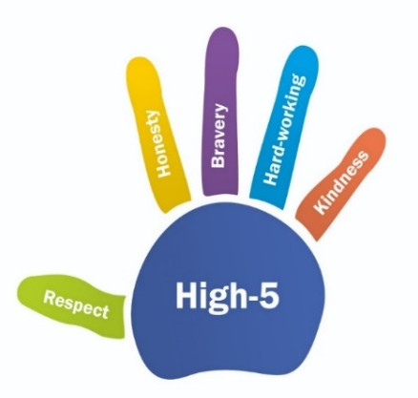
These are our ‘High 5 Values’
Respect | Honesty | Bravery | Hardworking | Kindness
We are good listeners.  We treat all people the same.  We respect other people’s views wishes or rights. | We present ourselves in an honest way and act in a sincere way.  We take responsibility of our feelings and actions. | We are willing to try new things.  We persevere in the face of adversity.  We stand up for what is right. | We finish what we start.  We keep going in spite of obstacles.  We take pleasure in completing tasks. | We are considerate of other people’s feelings.  We are patient and understanding.  We show empathy towards others.
These values are shared and discussed with all classes at the beginning of each school year and referred to regularly. Class teachers work with the children to establish their own class contracts or charters based on this set of expectations. Children are made aware of the behaviour expectations as soon as they start school in Reception and they are taught how to manage and understand their own behaviour throughout the school.
Fish Philosophy
Fish Philosophy is all about making our school a positive learning environment; a fun, happy and caring place, where people want to be.
The philosophy started at the Pike Place Fish Market in Seattle, which was once a horrid place to work with very high staff turnover. They decided they could not continue the way they were, instead choosing to make the best of a tough situation. Now, the Pike Place Fish Market has become a famous tourist destination, after following four key principles:
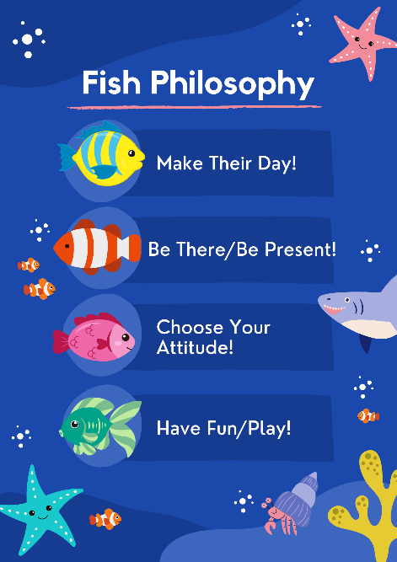
Make their day:
Making someone's day is all about sharing good feelings with others. We can praise them or notice others in some way and it not only helps to make their day better, but ours too!
Be there:
Being there is all about making sure our brains stay switched on. It is sometimes hard to stay focused and pay attention all the time. When we try to be there, we are making a real effort to try to keep focused and continue learning.
Choose your attitude:
Choosing your attitude is about being really positive, even if you haven't had a good start to the day.
It is up to you how the rest of the day goes and if you decide to try really hard, it will make a difference.
Play:
We have to make our learning as fun as possible, but remember, this has to be appropriate. At the right times, play can really make us feel better!
An extensive PSHE curriculum including the teaching of the core British values of democracy, the rule of law, individual liberty and mutual respect and tolerance of those of different beliefs, helps children to understand the need for everyone to work towards a set of common expectations. It also teaches children how to understand and manage conflict and helps them to resolve differences with other people. The curriculum, as well as other extracurricular opportunities given to the children such as class and whole school responsibilities, enhance self-esteem by building a sense of identity, security, belonging, purpose and competence. It also enables them to understand and express their own feelings. Children with a high self-esteem and self-confidence are more likely to behave appropriately and be able to show empathy and understanding towards others.
- Rewarding Good Behaviour
At Runwell Community Primary School we endeavour to praise each child every day with a particular emphasis on recognising the effort the learner has been displaying. It is important that the child knows and understands why they are receiving a praise or a reward.
Clear unambiguous school rules, known as ‘Our High 5’s’. These are known to staff, pupils and parents and are displayed throughout the school.
A summary of the adult responses used to reward good behaviour are shown in Appendix 2 – this summary is distributed to parents each year at the ‘Meet the Teacher’ session in September. This list is not exhaustive but represents the key habits and routines expected and celebrated within the whole-school culture.
Routine rewards available to all learners at Runwell include:
- Our Dojo Shop: At Runwell our children will also have the opportunity to save up dojo points to be able to buy items or experiences from our school dojo shop. They are able to save up on an individual or class basis for these items.
- High 5 Time: At Runwell each class can earn ‘High 5’ time by earning enough marbles to fill their class jar. High 5 time is earnt by the whole class and each child gets to take part. Each time a class earn their high 5 time a marble is added to the whole school Runwell Jar. Once the jar is full the whole school get a joint High 5 time reward.
- Weekly certificates: During weekly assemblies, certificates are awarded.
- How we Support our Learners and Young People
Zones of Regulation – A strategy whereby learners can assign a feeling/emotion to a colour. The learners decide which colour they are currently in. If they feel that they would like to alter this (as they might be feeling angry/sad/over excited) then they can refer to their ‘Tools’. Tools are the strategies that the child can action to help them get back to the ‘Green Zone’ which is associated with being calm and ready/focussed to learn. More information can be found at: https://www.zonesofregulation.com/index.html

Zen Zones – Each class and a selection of offices within the school have identified Zen Zones. These zones contain resources that encourage children to calm, reflect and focus. Children may choose to stay in this zone, or if agreed by staff, may use the resource at their table/carpet space.

Use of de-escalation scripts (See appendix 10) through emotional containment phrases- To use a consistent limited language to reduce the risk of a stress response.
Such as:

- I can see that something has happened, I am here to help.
- Talk and I will listen
- I am here when you need me
- You are letting me know that you are feeling…
- I understand that you need some space, when you are ready, we can…
- It’s okay, I am here to keep you safe.

Co-regulation strategies (See appendix 11) –Reducing the fizzy. Support a pupil to begin to develop the capacity to self-regulate
Such as:
- Child’s name
- Child’s name, it is OK to be angry
- But it is not OK to swear.
- Talk and I will listen
- Let's ………….. or …………….
- Reflective meeting or chat

Co -regulation body language:
- Outside of an outstretched arm
- Good distance
- Sideways stance
- Leaving an open door
- Relaxed hands
- Managing height

Okay not okay boards – A visual plan which highlights behaviours that are ‘okay’ and those that are ‘not okay’. These are based on the behaviours that the learner is displaying. The consequences for these behaviours are also listed.

5 Step Adult Response Plans (see appendix 5) –Plans are written by professionals working with the learner, who know the learner well. This plan highlights behaviours, triggers and outlines the most proactive way that staff working with this learner can behave in response in detail.

Consistent Management Plans (see appendix 7) - This document highlights a learner’s behaviours, triggers and responses. This document is a ‘snapshot’ for any member of staff working with the learner.

Reflective approach and Restorative meetings ((See appendix 8 & 9) – This process allows the learner to take time to reflect on their behaviours as well as other learners that might be involved. A full Restorative conversation is conducted by a member of staff. During this time the staff member skilfully facilitates a discussion between all stakeholders. The aim of this intervention is for all involved to feel listened to, but to also understand different perspectives of the same incident. It is hoped by the end of the conversation that learners have reflected and understood the incident fully. It is hoped that learners will consider how they can ‘restore’ the relationship. This method connects impacts of choices made to emotions and feelings.

This list is by no means exhaustive, and some learners require different approaches.
- Managing Undesirable Behaviour
At Runwell Community Primary School, we actively avoid sanctions or consequences where a child is made to feel shame or humiliation. For this reason, practices such as traffic lights on walls and weather charts are not used. Behaviour is improved by building children’s self-esteem and helping them to believe that they can make the right choices, that they are kind and they are capable of behaving well. We deal with incidents of disruptive or unsocial behaviour in a way that avoids shame and punitive responses and punishments. We celebrate and praise in public and reprimand in private. We aspire to foster an atmosphere where children have the chance to reflect upon the impact that their behaviour has on other people, including teaching staff.
The ethos of the school is one of collaboration, support and mutual respect. For that reason, it is important that all staff feel empowered to challenge disruptive behaviours. Evidence suggests that pupils do better where they have strong relationships with staff as it is these staff who will be able to support them at the times of most difficulty. The steps staff will follow are outlined in Appendix 3. At Runwell, we also use STAR analysis, to identify trigger points and put actions in place to support the child.
Appendix 3 shows a table of examples of ‘Behaviour Levels at Runwell’ (please note that these are examples and NOT an exhaustive list)

Difficult and Dangerous behaviour
The rewards systems and steps outlined in Appendix 2 should be sufficient for the majority of pupils. There will, however, always be a minority of pupils in any school whose needs are such that they lead to difficult behaviour. Schools should seek to understand this behaviour and meet the needs of these pupils. All responses to difficult behaviour should be consistent, respectful, calm and logical, and where possible, in private.
Difficult behaviour, in the school context, encompasses behaviour that has duration, frequency, intensity or persistence and is beyond the typical range for the school. It generally:
- interferes with the pupil’s own and / or other pupils’ learning;
- disrupts the day to day functioning of the school, making it a less safe and orderly environment
- is less likely to be responsive to the usual range of interventions identified within the school behaviour policy
It should be recognised that difficult behaviour may also include withdrawn behaviour, including refusal to respond or engage.
Steps to dealing with difficult behaviour can be found in Appendix 1
Dangerous behaviour in the school context encompasses behaviour that is generally:
- likely to result in imminent harm to others or self (including pushing, punching, kicking, biting, scratching, spitting, head-butting, stabbing)
- verbally abusive (and may include racist/homophobic/sexist abuse)
- destructive, including significant destruction of property and the environment
- self-harming, including head banging, scratching, hitting, kicking, biting and poking, striking another adult / pupil with an object.
Most pupils do not display dangerous behaviour, however, when such incidents occur, they are deemed serious and can cause a great deal of stress for those involved. Best practice expects that Adult Response Plans will be used to prevent dangerous behaviour; assess, plan, do and review. This will ensure that effective ‘adult response plans’ are in place for those children requiring them. The key to the success of any plan is that it is fully discussed, understood and implemented consistently by all staff, pupils and parents / carers.
When faced with potentially dangerous behaviour, we will attempt to de-escalate it. The use of a ‘script’ is advised. The pupil should be spoken to calmly, assertively and respectfully at all time. Simple deescalation phrases are recommended: for example;
- Name (Use the pupil’s name)
- I can see there’s something wrong (acknowledge their right to their feelings)
- I’m here to help (tell them why you are here)
- Talk and I’ll listen (it may be possible for staff to find out how the situation has developed, or how it may be resolved).
- Come with me and we can…… (give them an ‘out’ to withdraw from the situation)
During this period, the pupil should be given physical space and time to recover and respond to requests. Where de-escalation has not been possible and difficult or dangerous be behaviour continues, they should be guided / supported from the classroom to a place of safety, with the assistance of another member of staff. Where this is not possible, an alternative is for the rest of the class to be removed from a potentially dangerous or harmful situation. Staff should always stay with the pupil, but at a safe distance (this is usually at least an extended arm’s length away from them). At this point, it is important not to raise the stress of the pupil further. Staff should maintain an open stance, actively guiding them to a place of safety, rather than blocking them or backing them into a corner, as this could escalate the situation. As part of safeguarding, following any serious harmful (or potentially harmful) incident, a risk assessment should be completed to inform planning and future practice.
Children who are physically or verbally violent towards another pupil or staff member are referred straight to a member of the senior leadership team and the behaviour is recorded. All bullying (including racist and homophobic) incidents are also referred to a member of the senior leadership team and are recorded on CPOMS. This will involve the Headteacher and relevant school staff working closely with the child and parents to address and resolve the misbehaviour. If necessary, an Adult Response Plan (Appendix 4) will be formed and this will involve specific rewards and sanctions, as governed by the plan.
Other sanctions for difficult, dangerous and bullying behaviours may include:
- loss or privileges (missed playtimes will be referred to time IN for restorative conversations to take place as opposed to time OUT)
- repeating unsatisfactory work until it meets the required standard
- doing a job for an adult under supervision e.g. tidying up (if regulated) linked to misbehaviour
- suspensions
- permanent exclusions
Sometimes poor behaviour choices continue to be made by children and this is detrimental to the learning, safeguarding and wellbeing of others and of the individual.
Such incidents might include (and this is NOT an exhaustive list) where:
- there is a repeat/constant flow of low-level disruption to their learning and the learning of others
- children take up a disproportionate amount of the class teachers or Senior Leader’s time in having to manage that pupil’s behaviour
- the behaviour has been particularly violent or malicious towards another person
- school property or another child’s work has been deliberately damaged or defaced
- a child potentially puts themselves or others at risk of harm by disobeying a direct instruction by a member of the SLT
- a child is sent out of the classroom to work with a member of the SLT on a regular basis
- repeatedly behaving in a way that is severely disrupting the school
In these types of circumstances, the SLT will put in place any consequences that they believe reflect the poor behaviour choices made. The aim of these consequences is to help the child to understand and be in no doubt that continuously poor behaviour is not acceptable at our school (just as it is not in wider society) and that such behaviour choices can have serious consequences for them.
One-off incidents of a severe nature might include, for example (and this is NOT an exhaustive list):
- seriously hurting others or causing deliberate injury or harm (physically or mentally)
- permanently defacing others work or school property
- leaving the classroom/school without consent
- deliberately breaking or misusing equipment
- spitting in another person’s face
- behaviour that puts themselves or others in significant danger
- fighting that leads to serious injury
- provoking another child which leads to fighting causing serious injury
- disobeying a direct request by a member of the SLT, so that their authority is undermined (once a child refuses a request in this way, their safety and the safety of others can no longer be guaranteed, which is a serious health and safety issue)
In response to a serious breach or persistent breaches of the school's behaviour policy; and where allowing the pupil to remain in school would, in the school’s opinion, seriously harm the education, safeguarding or welfare of the pupil or others, the Headteacher will exercise the right to suspend or exclude a child. Depending upon the seriousness of the incident, this may be for a fixed term suspension or a permanent exclusion. Prior to deciding to exclude a child permanently, the Headteacher may approach the school’s Inclusion Partner or the headteacher of another school to set up a managed move, so that the child can have a fresh start in a new establishment. In such cases, we will operate a thorough handover with the receiving school to ensure all necessary resources are put in place
We are an inclusive school and do not wish to exclude any child, even when they exhibit serious behavioural difficulties. We will take every reasonable step to ensure that suspensions are avoided. However, in extreme cases, it may be necessary to exclude. The Headteacher can exclude a pupil from the school on disciplinary grounds for the maximum of 45 academy days per academic year. After this, the pupil may be permanently excluded.
- Bullying
Bullying is defined as the repetitive, intentional harming of 1 person or group by another person or group, where the relationship involves an imbalance of power.
Bullying is, therefore:
- Deliberately hurtful
- Repeated, often over a period of time
- Difficult to defend against
Bullying can include:
TYPE OF BULLYING | DEFINITION
Emotional | Being unfriendly, excluding, tormenting
Physical | Hitting, kicking, pushing, taking another’s belongings, any use of violence
Prejudice-based and discriminatory, including:  - Racial  - Faith-based  - Gendered (sexist)  - Homophobic/biphobic  - Transphobic  - Disability-based | Taunts, gestures, graffiti or physical abuse focused on a particular characteristic (e.g. gender, race, sexuality)
Sexual | Explicit sexual remarks, display of sexual material, sexual gestures, unwanted physical attention, comments about sexual reputation or performance, sharing of nude or semi-nude images and/or videos (including pseudo-images, which are computer-generated images that otherwise appear to be a photograph or video), or inappropriate touching
Direct or indirect verbal | Name-calling, sarcasm, spreading rumours, teasing
Cyber-bullying | Bullying that takes place online, such as through social networking sites, messaging apps, gaming sites, devices or via images, audio, video, or written content generated by artificial intelligence (AI)
Details of our school’s approach to preventing and addressing bullying are set out in our anti-bullying strategy here:
Anti-Bullying Policy
- Responding to misbehaviour from children with SEND
Recognising the impact of SEND on behaviour
The school recognises that pupils’ behaviour may be impacted by a Special Educational Need or Disability (SEND).
When incidents of misbehaviour arise, we will consider them in relation to a pupil’s SEND, although we recognise that not every incident of misbehaviour will be connected to their SEND. Decisions on whether a pupil’s SEND had an impact on an incident of misbehaviour will be made on a case-by-case basis.
When dealing with misbehaviour from pupils with SEND, especially where their SEND affects their behaviour, the school will take its legal duties into account when making decisions about enforcing the behaviour policy. The legal duties include:
Taking reasonable steps to avoid any substantial disadvantage to a disabled pupil being caused by the school’s policies or practices (Equality Act 2010)
Using our best endeavours to meet the needs of pupils with SEND (Children and Families Act 2014)
If a pupil has an Education, Health and Care (EHC) plan, the provisions set out in that plan must be secured and the school must co-operate with the local authority and other bodies.
As part of meeting these duties, the school will anticipate, as far as possible, all likely triggers of misbehaviour, and put in place support to prevent these from occurring.
Any preventative measures will take into account the specific circumstances and requirements of the pupil concerned.
Our approach for removing triggers for pupils with SEND could include:
- Short, planned movement breaks for a pupil with SEND who finds it difficult to sit still for long
- Adjusting seating plans to allow a pupil with visual or hearing impairment to sit in sight of the teacher
- Adjusting uniform requirements for a pupil with sensory issues or who has severe eczema
- Training for staff in understanding conditions such as autism
- Use of safe spaces space where pupils can regulate their emotions during a moment of sensory overload
Adapting sanctions for pupils with SEND
When considering a behavioural sanction for a pupil with SEND, the school will consider whether:
- The pupil was unable to understand the rule or instruction
- The pupil was unable to act differently at the time as a result of their SEND
- The pupil was likely to behave aggressively due to their particular SEND
If the answer to any of these is ‘yes’, it may be unlawful for the school to sanction the pupil for the behaviour.
The school will then assess whether it is appropriate to use a sanction and if so, whether any reasonable adjustments need to be made to the sanction.
While any support deemed appropriate is put in place, the school will still carry out its duty to ensure the majority of children do not have their right to a good education disrupted, that everyone is kept safe and are treated with dignity and respect. The support the school can give to a pupil and the consequences of any ongoing poor behaviour choices are not mutually exclusive. The consequences will be proportionate to the poor behaviour and as children are individuals and all incidents unique, so the consequences decided upon will be based on a range of factors, including all of the information we have on a child at that time. This means that while every child has the right to learn, and that school will exercise its best endeavors to support a child to do so, no child has the right to disrupt the learning of others. When making decisions, the school must balance the needs of the individual with those of the school community. Where pupil behaviour places others at risk, the safety of the pupil body as a whole is paramount
Considering whether a pupil displaying challenging behaviour may have unidentified SEND
The school’s Special Educational Needs Co-ordinator (SENCO) may evaluate a pupil who exhibits challenging behaviour to determine whether they have any underlying needs that are not currently being met.
Where necessary, support and advice will also be sought from specialist teachers, an educational psychologist, medical practitioners and/or others, to identify or support specific needs.
When acute needs are identified in a pupil, we will liaise with external agencies and plan support programmes for that child. We will work with parents/carers to create the plan and review it on a regular basis.
Pupils with an Education, Health and Care (EHC) Plan
The provisions set out in the EHC plan must be secured and the school will co-operate with the local authority and other bodies.
If the school has a concern about the behaviour of a pupil with an EHC plan, it will make contact with the local authority to discuss the matter. If appropriate, the school may request an emergency review of the EHC plan.
South Essex 0333 013 4736 or SENDOperations.South@essex.gov.uk
- Recording / Reporting of Behaviour Incidents
Staff will ensure that incidents are recorded and communicated with parents / carers when appropriate.

If a child displays a behaviour that is level 2 or above, then staff members will record this via our CPOMS monitoring system. Behaviour incidents are logged by all staff using a STAR analysis. (Setting, Trigger, Action and Result) This enables the school to log, monitor and analyse behaviours on an individual, year group and whole school basis.

STAR Analysis:
S – Setting
T – Triggers, or potential triggers
A – Action (Communicating behaviour)
R – Response – including actions by adult

Example:
S – Classroom
T – Maths is least favourite subject, got an answer wrong
A – XY does not like maths, log division proved quite tricky and when they got an answer wrong they became frustrated and demanded immediate support. When this was not immediately available they walked out of class and kicked XX chair on the way to causing them to fall.
R – LSA went out to support TT regulation. Offered support for maths work. XY came back into the classroom. After some time Class teacher completed restorative conversation – Restorative meeting completed with class teacher

When a child demonstrates a level 3-5 behaviour parents are informed by the appropriate adult (see appendix 3)
- Harm from Dysregulated (stressed) Behaviour
Our school always prioritises the safety and welfare of all staff and children/young people, recognising that everyone is entitled to a safe and supportive environment. Any incident (verbal or physical) which compromises safety can be perceived as dangerous. Our staff understand through training that this behaviour is not necessarily deliberate, rather it is often due to a stress response.
Supporting those who have been harmed
Our staff and children and young people receive the individual support they need in response to any incident where the behaviour has compromised the wellbeing of someone else, causing harm. Occasionally there may be times, despite all reasonably practicable measures being taken, when prevention is unsuccessful, and someone is harmed. At these times our school ensures that this person (adult or child/young person) is fully supported.
We always consider the following:
- are they physically safe and protected?
- do they need immediate first aid & medical treatment?
- is there a need for immediate police involvement?
- ensure they have the opportunity to talk about the incident either with a trusted person or other independent service
- give reassurance to reduce feelings of guilt and/or anxiety
- Transitions
For pupils entering Reception, where they have been offered a place, teachers will aim to meet the pupils and parents/carers before starting school (either in their homes or in previous settings).
To ensure a smooth transition to the next year, children have transition sessions with their new teacher(s). In addition, staff members hold transition meetings. To ensure behaviour is continually monitored and the right support is in place, information related to child behaviour issues may be transferred to relevant staff at the start of the term or year. Support will be offered to pupils with specific needs during these periods. Information on behaviour issues may also be shared with new settings for those children transferring to other schools.
- Safeguarding
The school recognises that changes in behaviour may be an indicator that a pupil is in need of help or protection.
We will consider whether a pupil’s misbehaviour may be linked to them suffering, or being likely to suffer, significant harm.
Where this may be the case, we will follow our child protection and safeguarding policy, and consider whether pastoral support, an early help intervention or a referral to children’s social care is appropriate.
Please refer to our child protection and safeguarding policy for more information. They can be found here.
- Risk Assessment Process
In our school we use a risk assessment process as the starting point for preventing harm for identified vulnerable children and young people. It identifies what is likely to cause stress to them, using all the information known about them. Once all this information is collated, a strategy for supporting a situation appropriately and keeping everyone safe can be developed. An example of information to be included in the risk assessment can be found in Appendix 6.
- Reasonable force
Reasonable force covers a range of interventions that involve physical contact with pupils. All members of staff have a duty to use reasonable force, in the following circumstances, to prevent a pupil from:
- Causing disorder
- Hurting themselves or others
- Damaging property
- Committing an offence
Incidents of reasonable force must:
- Always be used as a last resort
- Be applied using the minimum amount of force and for the minimum amount of time possible
- Be used in a way that maintains the safety and dignity of all concerned
- Never be used as a form of punishment
- Be recorded on CPOMs and reported to parents
When considering using reasonable force, staff should, in considering the risks, carefully recognise any specific vulnerabilities of the pupil, including SEND, mental health needs or medical conditions
- Confiscation and searches
Confiscation
Any prohibited items (See list below) found in a pupil’s possession as a result of a search will be confiscated. These items will not be returned to the pupil.
- We will also confiscate any item that is harmful or detrimental to a smooth and safe running of the school. These items will be returned to pupils after discussion with senior leaders and parents, if appropriate.
- Possession of any prohibited items. These are:
- Knives or weapons
- Alcohol
- Illegal drugs
- Stolen items
- Tobacco and cigarette papers/Vapes
- Fireworks
- Pornographic images
- Any article a staff member reasonably suspects has been, or is likely to be, used to commit an offence, or to cause personal injury to, or damage to the property of, any person (including the pupil)
Searching a pupil
Searches will only be carried out by a member of staff who has been authorised to do so by the headteacher, or by the headteacher themselves.
Subject to the exception below, the authorised member of staff carrying out the search will be of the same sex as the pupil, and there will be another member of staff present as a witness to the search.
An authorised member of staff of a different sex to the pupil can carry out a search without another member of staff as a witness if:
- The authorised member of staff carrying out the search reasonably believes there is risk that serious harm will be caused to a person if the search is not carried out as a matter of urgency; and
- In the time available, it is not reasonably practicable for the search to be carried out by a member of staff who is the same sex as the pupil; or
- It is not reasonably practicable for the search to be carried out in the presence of another member of staff
When an authorised member of staff conducts a search without a witness they should immediately report this to another member of staff, and ensure a written record of the search is kept.
If the authorised member of staff considers a search to be necessary, but is not required urgently, they will seek the advice of the headteacher, designated safeguarding lead (or deputy) or pastoral member of staff who may have more information about the pupil. During this time the pupil will be supervised and kept away from other pupils.
A search can be carried out if the authorised member of staff has reasonable grounds for suspecting that the pupil is in possession of a prohibited item or any item identified in the school rules for which a search can be made, or if the pupil has agreed.
An appropriate location for the search will be found. Where possible, this will be away from other pupils. The search will only take place on the school premises or where the member of staff has lawful control or charge of the pupil, for example on a school trip.
Before carrying out a search the authorised member of staff will:
- Assess whether there is an urgent need for a search
- Assess whether not doing the search would put other pupils or staff at risk
- Consider whether the search would pose a safeguarding risk to the pupil
- Explain to the pupil why they are being searched
- Explain to the pupil what a search entails – e.g. I will ask you to turn out your pockets and remove your scarf
- Explain how and where the search will be carried out
- Give the pupil the opportunity to ask questions
- Seek the pupil’s co-operation
If the pupil refuses to agree to a search, the member of staff can give an appropriate behaviour sanction.
If they still refuse to co-operate, the member of staff will contact the headteacher / designated safeguarding lead (deputy) / DHT, to try and determine why the pupil is refusing to comply.
The authorised member of staff will then decide whether to use reasonable force to search the pupil. This decision will be made on a case-by-case basis, taking into consideration whether conducting the search will prevent the pupil harming themselves or others, damaging property or from causing disorder.
The authorised member of staff can use reasonable force to search for any prohibited items identified and listed under prohibited items, but not to search for items that are only identified in the school rules.
The authorised member of staff may use a metal detector to assist with the search.
An authorised member of staff may search a pupil’s outer clothing, pockets, possessions, desks or lockers.
Outer clothing includes:
- Any item of clothing that is not worn immediately over a garment that is being worn wholly next to the skin or being worn as underwear (e.g. a jumper or jacket being worn over a t-shirt)
- Hats, scarves, gloves, shoes, boots
Searching pupils’ possessions
Possessions means any items that the pupil has or appears to have control of, including:
- Desks
- Bags
A pupil’s possessions can be searched for any item if the pupil agrees to the search. If the pupil does not agree to the search, staff can still carry out a search for prohibited items (listed in section 3) and items identified in the school rules.
An authorised member of staff can search a pupil’s possessions when the pupil and another member of staff are present.
If there is a serious risk of harm if the search is not conducted immediately, or it is not reasonably practicable to summon another member of staff, the search can be carried out by a single authorised member of staff.
Informing the designated safeguarding lead (DSL)
The staff member who carried out the search should inform the DSL without delay:
- Of any incidents where the member of staff had reasonable grounds to suspect a pupil was in possession of a prohibited item as listed in section 3
- If they believe that a search has revealed a safeguarding risk
All searches for prohibited items (listed in section 3), including incidents where no items were found, will be recorded in the school’s safeguarding system.
Informing parents
Parents will always be informed of any search for a prohibited item (listed in section 3). A member of staff will tell the parents as soon as is reasonably practicable:
- What happened
- What was found, if anything
- What has been confiscated, if anything
- What action the school has taken, including any sanctions that have been applied to their child
Support after a search
Irrespective of whether any items are found as the result of any search, the school will consider whether the pupil may be suffering or likely to suffer harm and whether any specific support is needed (due to the reasons for the search, the search itself, or the outcome of the search).
If this is the case, staff will follow the school’s safeguarding policy and speak to the designated safeguarding lead (DSL). The DSL will consider if pastoral support, an early help intervention or a referral to children’s social care is appropriate.
Strip searches
The authorised member of staff’s power to search outlined above does not enable them to conduct a strip search (removing more than the outer clothing) and strip searches on school premises shall only be carried out by police officers in accordance with the Police and Criminal Evidence Act 1984 (PACE) Code C.
Before calling the police into school, staff will assess and balance the risk of a potential strip search on the pupil’s mental and physical wellbeing and the risk of not recovering the suspected item.
Staff will consider whether introducing the potential for a strip search through police involvement is absolutely necessary, and will always ensure that other appropriate, less invasive approaches have been exhausted first.
Once the police are on school premises, the decision on whether to conduct a strip search lies solely with them. The school will advocate for the safety and wellbeing of the pupil(s) involved. Staff retain a duty of care to the pupil involved and should advocate for pupil wellbeing at all times.
Communication and record-keeping
Where reasonably possible and unless there is an immediate risk of harm, staff will contact at least 1 of the pupil’s parents to inform them that the police are going to strip search the pupil before strip search takes place, and ask them if they would like to come into school to act as the pupil’s appropriate adult. If the school can’t get in touch with the parents, or they aren’t able to come into school to act as the appropriate adult, a member of staff can act as the appropriate adult (see below for the role of the appropriate adult).
The pupil’s parents will always be informed by a staff member once a strip search has taken place. The school will keep records of strip searches that have been conducted on school premises, and monitor them for any trends that emerge.
Who will be present?
For any strip search that involves exposure of intimate body parts, there will be at least 2 people present other than the pupil, except in urgent cases where there is risk of serious harm to the pupil or others.
One of these must be the appropriate adult, except if:
- The pupil explicitly states in the presence of an appropriate adult that they do not want an appropriate adult to be present during the search, and
- The appropriate adult agrees
If this is the case, a record will be made of the pupil’s decision and it will be signed by the appropriate adult.
No more than 2 people other than the pupil and appropriate adult will be present, except in the most exceptional circumstances.
The appropriate adult will:
- Act to safeguard the rights, entitlement and welfare of the pupil
- Not be a police officer or otherwise associated with the police
- Not be the headteacher
- Be of the same sex as the pupil, unless the pupil specifically requests an adult who is not of the same sex
Except for an appropriate adult of a different sex if the pupil specifically requests it, no one of a different sex will be permitted to be present and the search will not be carried out anywhere where the pupil could be seen by anyone else.
Care after a strip search
After any strip search, the pupil will be given appropriate support, irrespective of whether any suspected item is found. The pupil will also be given the opportunity to express their views about the strip search and the events surrounding it.
As with other searches, the school will consider whether the pupil may be suffering or likely to suffer harm and whether any further specific support is needed (due to the reasons for the search, the search itself, or the outcome of the search).
Staff will follow the school’s safeguarding policy and speak to the designated safeguarding lead (DSL). The DSL will consider if, in addition to pastoral support, an early help intervention or a referral to children’s social care is appropriate.
Any pupil(s) who have been strip searched more than once and/or groups of pupils who may be more likely to be subject to strip searching will be given particular consideration, and staff will consider any preventative approaches that can be taken.
- Mobile phones
At Runwell Community Primary we understand that some of our year 5 and year 6 learners may wish to walk home by themselves. Many parents/carers therefore ask for their children to carry a mobile phone.
Phones are handed to the class teacher at the start of each day and will not be returned until the end of the school day. The phone will be stored in a drawer/cupboard within the classroom. Children are not permitted to keep their phones upon their persons or in their bag/coat during the school day.
We ask that children to not use their phones in school as this mitigates the risks of distraction, disruption, bullying and abuse.
Pupils are able to turn their phones on when they leave the school site at the end of the school day.
The school will not accept liability in the case of loss or damage to the phone/phone accessories.
In the event that a child does not follow these requirements SLT will discuss with Parent/carer their child’s future use of mobile phones in school. This may result in the child being asked not to bring the phone to school moving forward.
- Off-site misbehaviour
Consequences may be applied where a pupil has misbehaved off-site when representing the school. This means misbehaviour when the pupil is:
- Taking part in any school-organised or school-related activity (e.g. school trips)
- Travelling to or from school
- Wearing school uniform
- In any other way identifiable as a pupil of our school
Consequences may also be applied where a pupil has misbehaved off-site, at any time, whether or not the conditions above apply, if the misbehaviour:
- Could have repercussions for the orderly running of the school
- Poses a threat to another pupil
- Could adversely affect the reputation of the school
Sanctions will only be given out on school premises or elsewhere when the pupil is under the lawful control of a staff member (e.g. on a school-organised trip).
Online misbehaviour
The school can issue behaviour consequences to pupils for online misbehaviour when:
- It poses a threat or causes harm to another pupil
- It could have repercussions for the orderly running of the school
- It adversely affects the reputation of the school
- The pupil is identifiable as a member of the school
Consequences will only be given out on school premises or elsewhere when the pupil is under the lawful control of a staff member.
Suspected criminal behaviour
If a pupil is suspected of criminal behaviour, the school will make an initial assessment of whether to report the incident to the police.
When establishing the facts, the school will endeavour to preserve any relevant evidence to hand over to the police.
If a decision is made to report the matter to the police, the Headteacher/ member of the SLT/AHT/ pastoral lead will make a report.
The school will not interfere with any police action taken. However, the school may continue to follow its own investigation procedure and enforce sanctions, as long as it does not conflict with police action.
If a report to the police is made, the designated safeguarding lead (DSL) will make a tandem report to children’s social care, if appropriate.
- Zero-tolerance approach to sexual harassment and sexual violence
The school will ensure that all incidents of sexual harassment and/or violence are met with a suitable response, and never ignored.
Pupils are encouraged to report anything that makes them uncomfortable, no matter how ‘small’ they feel it might be.
The school’s response will be:
- Proportionate
- Considered
- Supportive
- Decided on a case-by-case basis
The school has procedures in place to respond to any allegations or concerns regarding a child’s safety or wellbeing. These include clear processes for:
- Responding to a report
- Carrying out risk assessments, where appropriate, to help determine whether to:
  - Manage the incident internally
  - Refer to early help
  - Refer to children’s social care
  - Report to the police
Please refer to our child protection and safeguarding policy for more information
- Malicious allegations
Where a pupil makes an allegation against a member of staff and that allegation is shown to have been deliberately invented or malicious, the school will consider whether to discipline the pupil in accordance with this policy.
Where a pupil makes an allegation of sexual violence or sexual harassment against another pupil and that allegation is shown to have been deliberately invented or malicious, the school will consider whether to discipline the pupil in accordance with this policy.
In all cases where an allegation is determined to be unsubstantiated, unfounded, false or malicious, the school (in collaboration with the local authority designated officer (LADO), where relevant) will consider whether the pupil who made the allegation is in need of help, or the allegation may have been a cry for help. If so, a referral to children’s social care may be appropriate.
The school will also consider the pastoral needs of staff and pupils accused of misconduct.
Please refer to our child protection and safeguarding policy for more information on responding to allegations of abuse against staff or other pupils.
- Professional Development for Staff
At Runwell, we believe that great professional development leads to great pedagogy. Staff will be trained in Trauma Perceptive Practice and on how to use the behaviour policy, in particular how to hold restorative and therapeutic conversations when challenging disruptive behaviour. It is important that staff feel empowered to deliver these conversations. Evidence suggests that pupils do better where they have strong relationships with staff as it is these staff who will be able to support them at the times of most difficulty.
Senior leaders will deliver support by standing alongside staff members and delivering on the spot coaching, where necessary. Staff can also access support to improve their practice, through training providers such as Juniper Education. Key members of staff will be trained in proper use of restraint by external providers.
- Suspension and Permanent Exclusion
The school would look to support pupils who demonstrate undesirable behaviours through pastoral support, such as Adult Response Plans, interventions such as Zones of Regulation and referrals to services such as CAMHS, Education Access and the school’s Inclusion Partner. Should these procedures fail to improve the child’s behaviour, or should the behaviour continue to deteriorate then a fixed term suspension may be imposed. A suspension will always be used as a last resort once all other attempts to improve behaviour have been attempted and failed. The only situations where a suspension will be used as an initial response to a behaviour incident is if another child or member of staff has sustained a significant injury requiring medical attention or a criminal or serious bullying offence has been committed. A serious bullying incident requiring a fixed term suspension would be defined as either causing significant harm to physical or mental health or repeated incidences of bullying despite support through restorative and educational meetings.
When making decisions, the school must balance the needs of the individual with those of the school community.
Where pupil behaviour places others at risk, the safety of the pupil body as a whole is paramount. When suspending or permanently excluding a child, reasons will be provided (see Appendix 13)
The school would follow the latest guidance as set out by the DfE, with regards to suspension and permanent exclusion
This policy should be read in conjunction with the policies for Teaching and Learning, Special Educational Needs, Child Protection and Anti-Bullying,

Appendix 1: Steps to dealing with difficult behaviour

Steps | Actions | Example
Redirection | Gentle encouragement, a ‘nudge’ in the right direction | “Come and sit on the carpet so that you are ready for your learning.” “Come and sit at your table so that you are ready to eat your lunch.”
Reminder | A reminder of the expectations (high 5s) delivered privately wherever possible. Reminders can repeated if necessary. De-escalate and decelerate behaviours where reasonable and possible and take the initiative to keep things at this stage. | “I noticed that you are…”
Warning | A clear, verbal warning delivered privately wherever possible, making the learner aware of their behaviour and clearly outlining the consequences if they continue. Offer a positive choice to do so. | In private:  “It was the rule about...that you broke. Please think carefully about what you are going to do next.
Timeout in class | Give the pupil a chance to reflect away from others in the classroom. Speak to the learner privately and give them a final opportunity to engage. Offer a positive choice to do so. | In private:  “You have chosen to have a time out because…”  After time out:  “Do you remember this morning/last week when you…..? That is the behaviour I need to see now,”
Time outside of class & Repair | At this point the learner will be referred internally and will work in an alternative classroom or space (preferably in partner class first). Where a child has had to be removed from a lesson, their parents will be informed and will be logged on CPOMS.  A restorative meeting should take place before the next lesson with relevant adult (see appendix 3). If this is unsuccessful the teacher should call on support from the Headteacher (or a senior leader) who will support the reparation process. This will take place at transition points such as playtime or lunchtime, in order to minimise further disruption to learning. | In private:  “You have chosen to leave the classroom because…”  Restorative meeting:  - What happened?  - How were you feeling at the time?  - How do you think other people felt?  - How do you feel now?  - How can we fix this?  - What can we do differently next time?

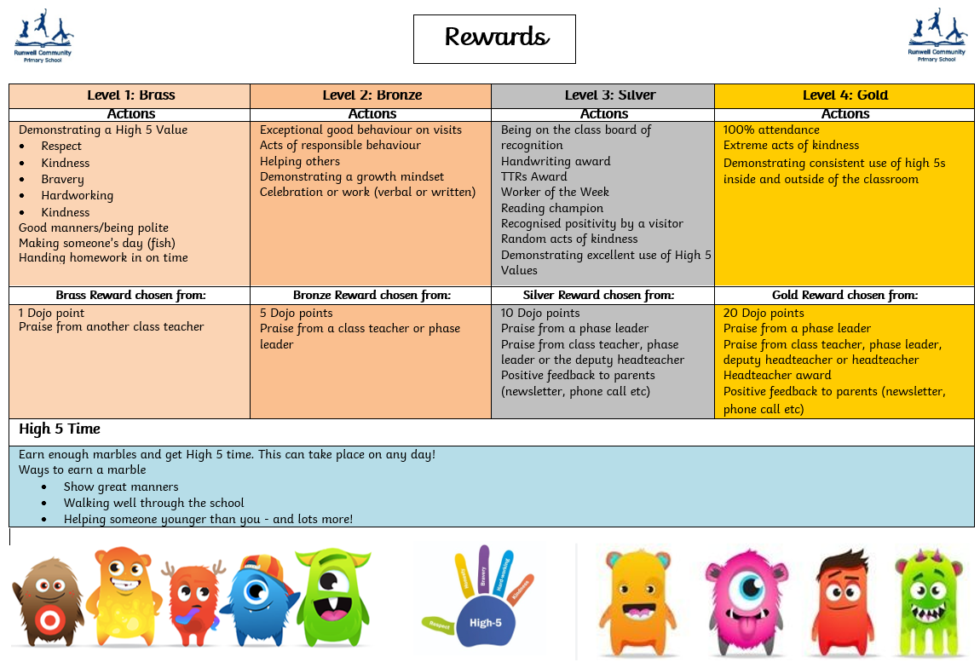
Appendix 2 - Runwell Community Primary Level of Rewards

Appendix 3 - Runwell Community Primary School Levels of Behaviour
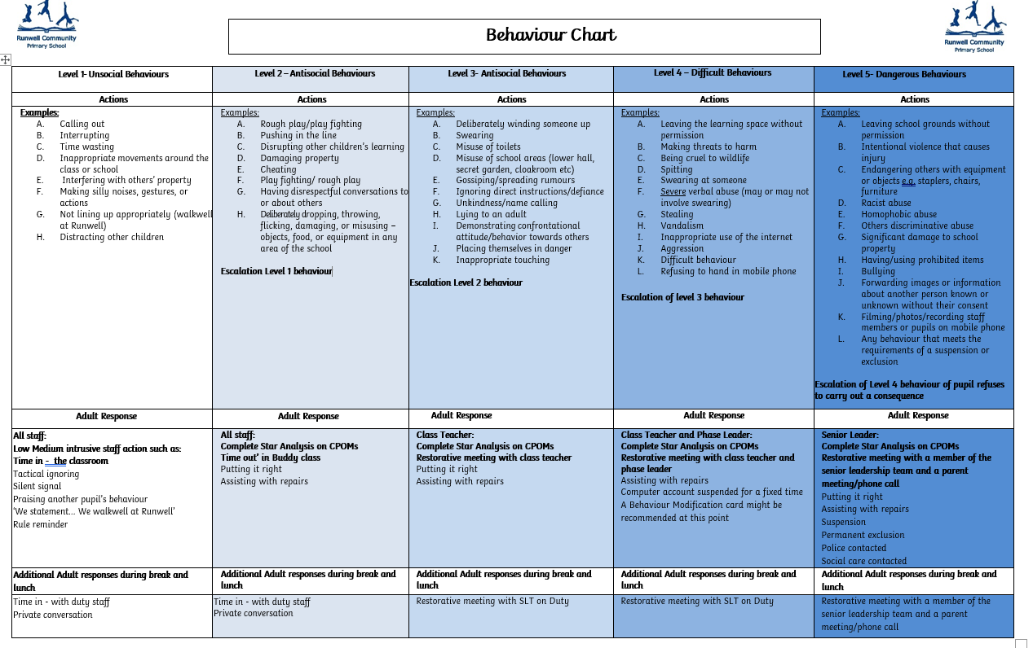

Appendix 4 - Behaviour Modification Card
Runwell Community Primary School

Name: | …………………………………………. | Class: | ………………………….. | Date: | ……………………..

 | Before School | 8:45am-10:30am | Break | 10:45am-12:00pm | Lunch | 1:00pm-2:00pm | 2.00pm:-3:15pm | After School
Monday
Tuesday
Wednesday
Thursday
Friday

This card must be given to your teacher to be completed at the end of the lesson.

Non negotiables: (usually no more than 3)
x
x
x

Appendix 5 - 5 Step Adult Response Strategy Plan

Pupil:………….……………………………………………… Year Group: ……………………………………

Key: Resources / Scripts / Communicated Feelings

Communicating Behaviours
Level 1 | Level 2 | Level 3 | Level 4 | Level 5
Calm and focused  Friendly  Good sense of humour  Positive communication  Engaged in an adult lead activity  Joining in, in class  Producing an outcome in class  Regulated  I am feeling calm  I feel safe  I am ready | Easily distracted  Not listening to adults  Not following a simple First / Then instruction  Leaves the learning environment  Engages in his own activity  Talks in a louder voice  Random noises  Random eye movement  Becomes tactile / tired  I am tired  I am beginning to feel overwhelmed  I am over stimulated | Shouting out loud  Hiding under spaces / tables  Lashes out  I am frustrated  I am cross  You are rude  I don’t want your help  I want to be left alone  I am Scared  I don’t want to do this | Scratching / biting supporting adults  Tipping furniture in a controlled manner  I am cross/angry  I want to be on my own | Hurting adults  Unpredictable behaviour  I am over stimulated  I am overwhelmed  I want to go home  I want my Mum
Adult Responses
Address him by full name  Positive praise  Smile  Soft tone  First / Then approach  Clear simple instructions  Tick sheet  Safe box  Comfort blanket  Sensory aids/toys  Ear defenders  Designated work space  Work screen  Zone of regulation  Books  Consequence cube  ‘Good morning xxx’  ‘Well done, xxx’  ‘Good listening, xxx’  STAFF FOCUSED PREVENTATIVE STRATEGIES | Limited language  Visual aids  Verbal First / Then  Proprioception aids  Reminders of expectations and consequences  Tick sheet  Safe box  Consequence cube  Sensory aids  Big blue mat in a safe zone  ‘xxx, we may need to use the consequence cube’  ‘No thank you xxx’  ‘First…/Then…..’ | Allow a safe and quiet space  Tactical ignoring  Time out  Modell calming strategies in the background but not directed at him  Distraction  Role play  Sensory calming aids  Safe box  Blanket  Books to read out loud  ‘I understand’  ‘I know’  ‘Don’t worry, it’s ok’ | Allow a safe and quiet space  Ensure the safety of others  Tactical ignoring  Verbal reassurance  Seek SLT  Change of adult  Change of adult who he has hurt  Safe box  Blanket  ‘It’s ok xxx, I am here to keep you safe’  ‘I am here when you are ready, it’s ok’  ADULTS TO COMPLETE STAR ANALYSIS | Allow a safe and quiet space  Ensure the safety of others  Tactical ignoring  Verbal reassurance  Seek SLT  Inform Head Teacher  Change of adult  Change of adult who he has hurt  Safe box  Blanket  ‘It’s ok xxx, I am here to keep you safe’  ADULTS TO COMPLETE STAR ANALYSIS

Appendix 6 – Risk Assessment Guidance
- Assess the risk and reducing the potential for harm
Adopting precautionary and preventative steps which help to avoid, prevent, minimise or mitigate incidents where staff can be harmed. Maintaining a sense of proportion in relation to the assessed risk. Best practice will be to involve parents/carers and the child or young person in this risk assessment process.
Possible questions to inform the risk assessment
- What harm could occur and how severe could this be? How likely is this harm?
- What information is provided for staff, how is it communicated?
- Is the right level of training provided to relevant staff?
- Are there changes needed to the way people carry out their duties or where they work?
- Has there been sufficient accounting of the site layout and the knowledge of the immediate working environment?
- Incident recording and response to incidents.
- How is any information, reports, involvement with other agencies such as the police and Children’s Social Care shared?
The assessment will include:
- Identified vulnerable child/young person (those that are most likely to become dysregulated when, where including activities and areas).
- Existing preventative measures and evaluation of the other potential risks.
- Additional preventative and control measures identified, including timescales.
- Communication procedures and review arrangements.
- Write an action plan
Any actions should be written monitored by Head Teacher/Senior Management and Governors to ensure that all items identified have sufficient resources allocated and have been addressed. The plan should be fit for purpose and tailored to managing the specific risk presented by identified child/young person or groups of children and young people.
The plan should include the following:
- Action required,
- Action by whom
- Risk priority
- Projected timescales
- Date completed
- Monitor, Review and update the assessment
Any risk assessment should be regularly reviewed and updated. It also should be visited again following a significant incident to reflect on any learning or additional protective measures.

Appendix 7 - Consistent Management Plan
Image of Learner

Name: | ………………………………………………….. | Date of Birth: | …………………………….………….
Class: | …………………………………………………. | Year: | …………………………………………

Strengths / Likes
Triggers / Difficulties
Preventative Strategies
Additional Information
Named adults will ensure your child is on track every day.
Named Adults:

Appendix 8 – Restorative Meeting Record
Restorative Meeting Record
Name: | Class: | Date:
Level 3: With CT | Level 4: With CT and PL | Level 5 With SLT


What happened

What were you thinking/feeling

What have you thought since?

Who was affected by this and how?
Which High 5 Value need repairing?
Respect | Honesty | Bravery | Hardworking | Kindness

How can you make things right?

Appendix 9 – Restorative Conversation Prompts for Lanyards
- Can you tell me what happened?  - What were you thinking/feeling at the time?  - How have you been thinking/feeling since it happened?  - Who do you think has been affected by your actions? How were they affected?  - What could you do now to help make things right?  - How can we prevent this from happening again in the future? What can I do to help you? | - Can you tell me what happened?  - What were you thinking/feeling at the time?  - How have you been thinking/feeling since it happened?  - Who do you think has been affected by your actions? How were they affected?  - What could you do now to help make things right?  - How can we prevent this from happening again in the future? What can I do to help you?

Appendix 10 – De-escalation Script for lanyards
STATE THE CHILD’S NAME  ”I can see that you are not feeling happy”  “It’s OK to not feel happy”  “It’s not okay to…”  “Would you like to share with me what has happened?”  “Let’s find a way to fix this together” | STATE THE CHILD’S NAME  ”I can see that you are not feeling happy”  “It’s OK to not feel happy”  “It’s not okay to…”  “Would you like to share with me what has happened?”  “Let’s find a way to fix this together”

Appendix 11 – Co regulation Script for lanyards
“Child’s name”  “Child’s name, it is OK to be angry”  “But it is not OK to swear.”  “Talk and I will listen”  “Let's ………….. or …………….”  Reflective meeting or chat | Co -regulation body language:  - Outside of an outstretched arm  - Good distance  - Sideways stance  - Leaving an open door  - Relaxed hands  - Managing height

Appendix 12 - SLANT and Walkwell
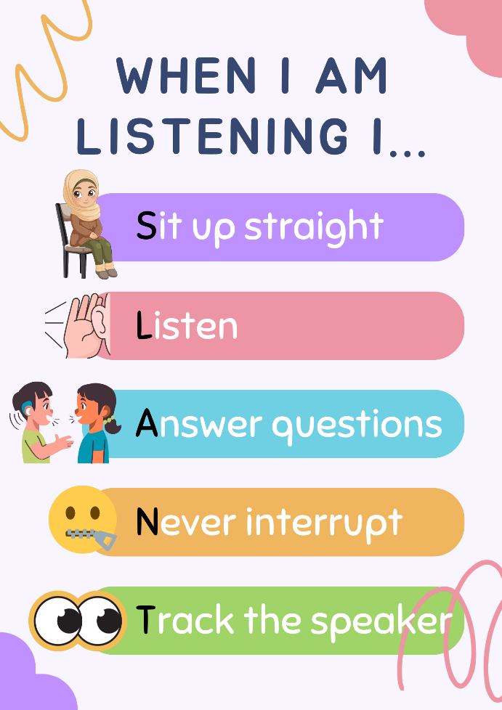 | 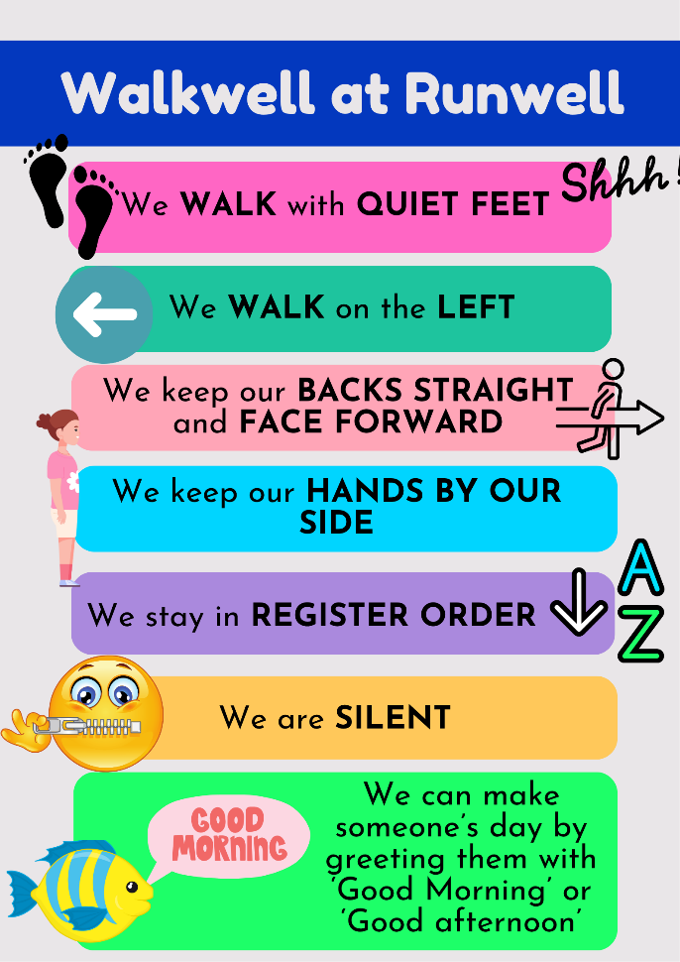 | 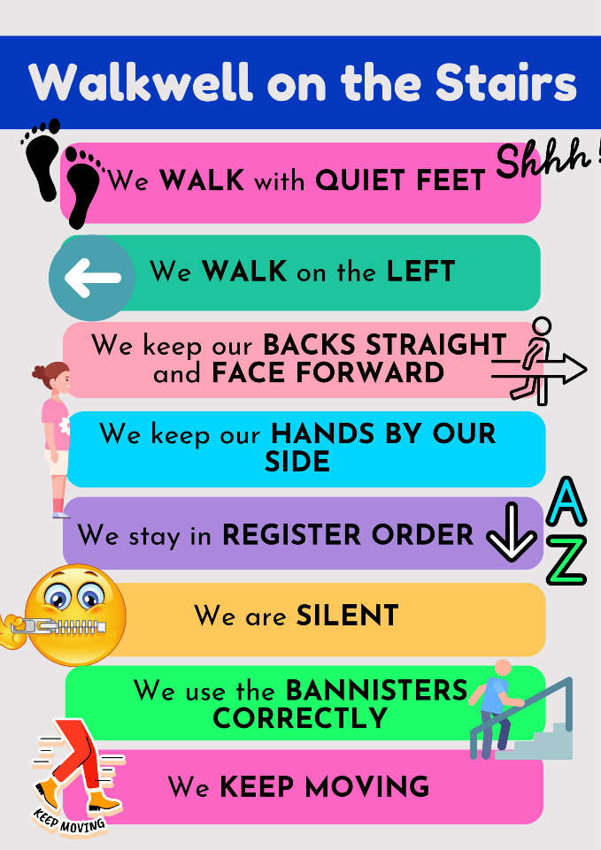

Appendix 13 - Reasons for suspension / permanent exclusion
The following Department for Education lists (which are not exhaustive) provide descriptors of reasons for suspension:
Physical assault against a pupil includes: | Physical assault against an adult includes: | Verbal abuse / threatening behaviour against pupil includes: | Verbal abuse / threatening behaviour against an adult includes: | Bullying includes | Racist abuse includes: | Sexual misconduct includes: | Drug and alcohol related includes: | Damage includes: | Theft includes: | Persistent disruptive behaviour includes:
- Fighting  - Violent behaviour  - Wounding  - Obstruction and jostling | - Violent behaviour  - Wounding  - Obstruction and jostling | - Threatened violence  - Aggressive behaviour  - Swearing (including online)  - Homophobic abuse and harassment (including online)  - Verbal intimidation (including online)  - Carrying an offensive weapon | - Threatened violence (including online)  - Aggressive Behaviour  - Swearing (including online)  - Homophobic abuse and harassment (including online)  - Verbal intimidation (including online)  - Carrying an offensive weapon | - Verbal bullying (including online)  - Physical bullying  - Homophobic bullying (including online)  - Racist bullying (including online) | - Racist taunting and harassment (including online)  - Derogatory racist statements (including online)  - Swearing that can be attributed to racist characteristics (including online)  - Racist bullying (including online  - Racist graffiti | - Sexual abuse  - Sexual assault  - Sexual harassment (including online)  - Lewd behaviour  - Sexual bullying (including online)  - Sexual graffiti | - Possession of illegal drugs  - Inappropriate use of prescribed drugs  - Drug dealing  - Smoking/vaping  - Alcohol abuse  - Substance abuse | - Vandalism  - Arson  - Graffiti | - Stealing school property  - Stealing personal property (pupil or adult)  - Stealing from local shops on school outing  - Selling and dealing in stolen property | - Challenging behaviour  - Disobedience  - Persistent violation of school rules
Other incidents may also be an excludable offence not covered by the categories above. For example, false allegations against a member of staff, or persistent non-compliance of staff instruction which leads to the risk of serious harm that would affect the safeguarding a pupil, pupils or staff

